Fastest Line Follower Bot:
Spec.1:
- STM32 "Black Pill" (STM32F411CEU6) -- 100MHz ARM Cortex-M4, Hardware FPU
- TB6612FNG Motor Driver -- 1.2A Continuous, 3.2A Peak
- 3S LiPo Battery -- 11.1V, ~350mAh, 70C
- 2x N20 Motors (w/ Encoders) – 12V N20 Gear Motors (w/ Encoders) - 1000 RPM, 1:20 Reduction Ratio (Gear Ratio)
- MP1584EN Buck Converter -- ~2.0A Continuous, Step-Down
- XL4015 Buck Converter -- 5A adjustable step-down (buck) DC-DC converter IC (Required for suction fan)
- N-Channel MOSFET -- IRLB8721 or IRLML2502 (digital switch, allowing the STM32 to safely turn the high-current coreless suction fan on and off)
- Flyback Diode -- 1N4007 or 1N5819 Schottky (absorb lethal voltage spikes when the suction fan powers down)
Spec. 2:
- STM32 "Black Pill"
- TB6612FNG
- 2S LiPo (7.4V, ~350mAh)
- 2x N20 Motors (Without Encoder) -- N20-6V-600 Rpm Micro Metal Gear Motor
- XL4015 Buck Converter
- N-Channel MOSFET -- IRLB8721 or IRLML2502
- Flyback Diode -- 1N4007 or 1N5819 Schottky

Line Follwer Based Maze Solver
Spec.1:
- ESP32 (WROOM-32)
- MCP3008 (SPI ADC)
- 12V N20 Gear Motors w/ Encoders (600 RPM)
- TB6612FNG
- MPU6050 Gyroscope
- 3S LiPo Battery (11.1V, 350mAh – 450mAh, 70C)
- MP1584 Buck Converter
Spec.2:
- ESP32 (WROOM-32)
- MPU6050 Gyroscope
- MCP3008 (SPI ADC)
- 6V N20 Gear Motors (600 RPM)
- TB6612FNG
- 2S LiPo Battery (7.4V, ~350mAh – 450mAh)
- MP1584 Buck Converter

STM32F411 Microcontroller
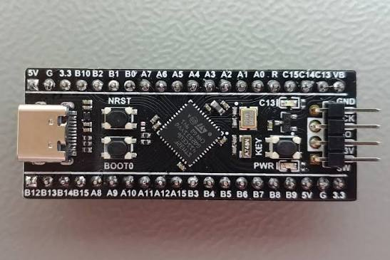

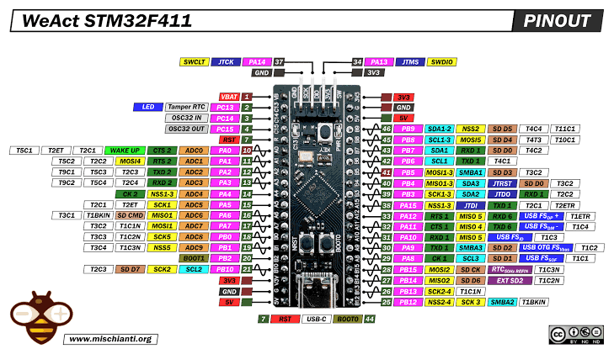
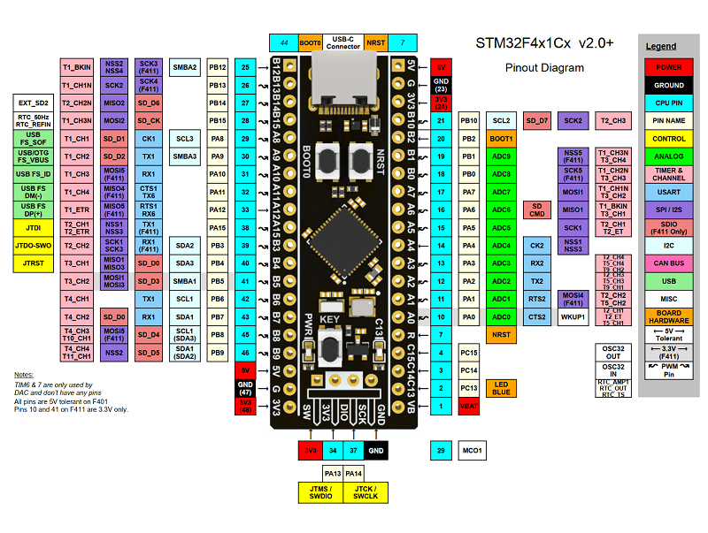
Take Reference for More details - https://stm32-base.org/boards/STM32F411CEU6-WeAct-Black-Pill-V2.0.html
Buying Link - https://share.google/8uT6CMw8DaNKjMOfd
https://share.google/yJcCNVwCj30VvOsUJ

Motor Driver – TB6612FNG

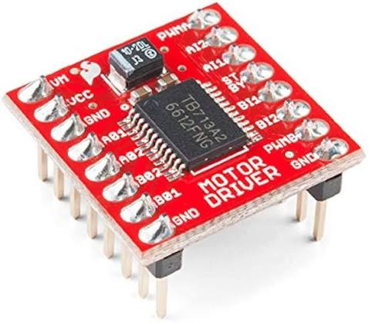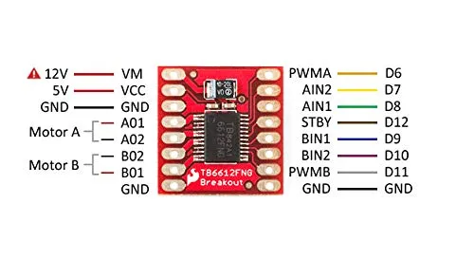

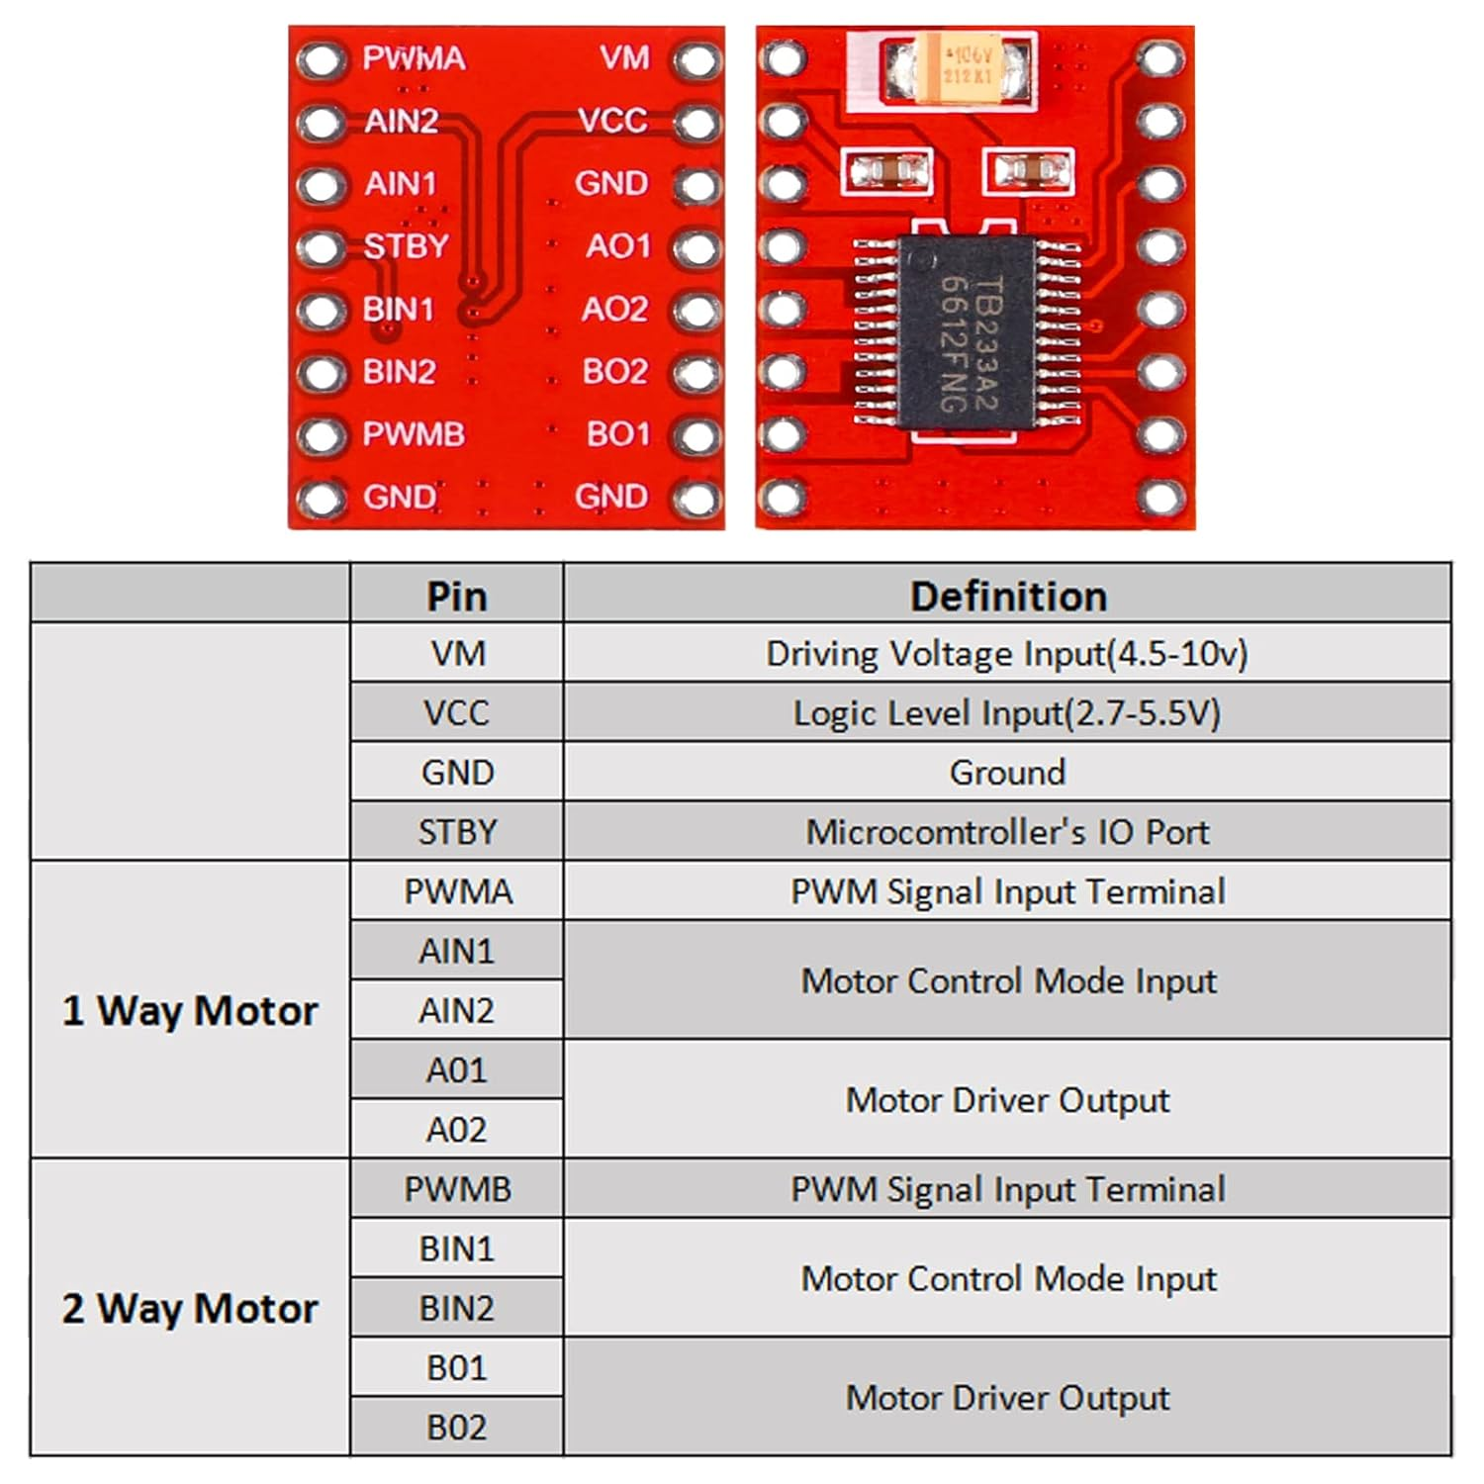
Reference - https://cdn.sparkfun.com/datasheets/Robotics/TB6612FNG.pdf
Buying Link - https://quartzcomponents.com/products/tb6612fng-dual-dc-motor-driver-module
https://robu.in/product/motor-driver-tb6612fng-module-performance-ultra-small-volume-3-pi-matching-performance-ultra-l298n/

Battery – LiPo 3S 11.1V 350mAh
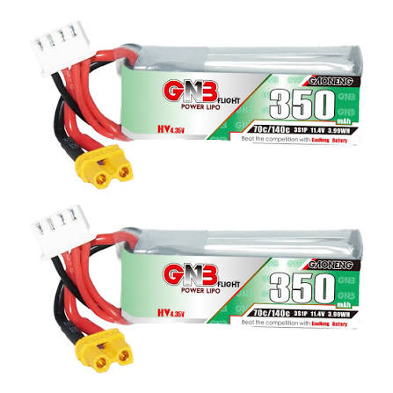
https://www.gaoneng.shop/products/gaoneng-gnb-lihv-3s-11.4v-350mah-70c-xt30-lipo-battery
Buck Converter
MP1584
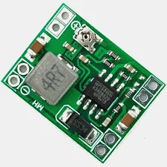
Buying Link - https://quartzcomponents.com/products/ultra-small-size-dc-dc-step-down-power-supply-module-3a-adjustable-buck-converter
Mini – 360
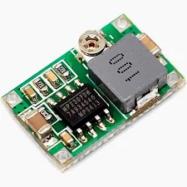
Buying Link - https://robu.in/product/mini-360-step-down-buck-converter-power-module/?gad_source=1&gad_campaignid=17416544847&gbraid=0AAAAADvLFWetfw8aeHukqJyx0hKrSuidA&gclid=CjwKCAjwl97RBhBWEiwAa9rbXVA6BIMKF19pQCvdulW9MSrOkY_w8scMH_9iMYSxmLNM8c-GrKnvdBoCNgEQAvD_BwE

XL4015 5A DC-DC Step Down Adjustable Power Supply Buck Module LED with Heatsink
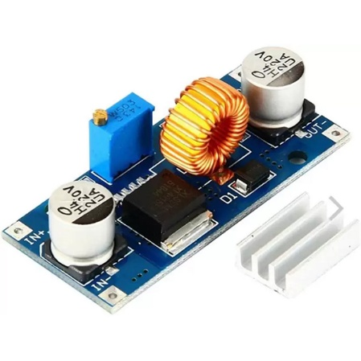
Specifications:
- Input voltage range: 4V-38V DC
- Output voltage range: 1.25V-36V DC adjustable.
- Output current: 0-5A.
- Output power: 75W.
- High efficiency up to 96%
- The built-in thermal shutdown function
- Built-in current limit function
- In-Built output short protection function
Buying Link - https://www.google.com/aclk?sa=L&ai=DChsSEwjPg8T2zt6VAxV-qGYCHYaHD-8YACICCAEQDRoCc20&co=1&ase=2&gclid=Cj0KCQjw6_HSBhCpARIsANvVltYfg9Ms79K2HR95jJT5yv0Ak9rJz8wZKc6GWJYCCO4b0q3Wcvj7krgaAnMhEALw_wcB&cid=CAASugHkaImWGj4uQMu61PqFt0hNDFd3Kj_RsqNDfpDbpbUvi1bXUXjahOLDcxtnHDQU7ob4ewgxlcpw4-Zb3AgDRYIbMz2n2OsFK4Sf3yuvtxpidDGqYlAYRfCzYLMO8As-tjs9KNRsXz8BMdZnoOCMOgzTvEA-Lc9zNJJAxPFK2omFBkSh0RJUyTs95sRNSMXcom9N1zYDfy4Hj7aBEwJaGi_orrsxD6UChNjAlsN_1ewc2RKcECRE0iOx4Ys&cce=2&category=acrcp_v1_32&sig=AOD64_38xt6rcstSvvtJnznW4_uuWJdx3w&ctype=5&q=&nis=4&ved=2ahUKEwiv27v2zt6VAxX_SmwGHWwlD1sQ5bgDKAB6BAgLEBA&adurl=

Motors :
N20-6V-600 Rpm Micro Metal Gear Motor without encoder
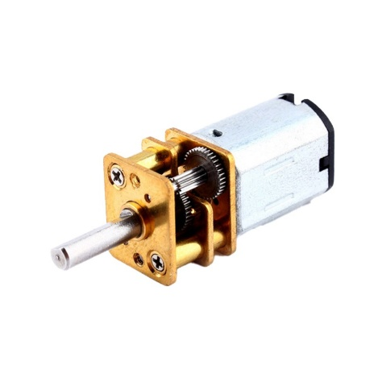
Buying -https://www.google.com/aclk?sa=L&ai=DChsSEwjpgdqKzt6VAxUurWYCHcrUCzgYACICCAEQChoCc20&co=1&ase=2&gclid=Cj0KCQjw6_HSBhCpARIsANvVltaBzMes4ina6oBaRrsk-xPdh-57sec9JNpLk8sO4n092sveSSI8GawaAljwEALw_wcB&cid=CAAS3QHkaPWrjGgLJWkP8rrhgKhG72Xykm5pQ0EFoAUnk_2RnnrE32dp5kiQGK7pVuOsfBPL4Yqy2vz49NpZvcwQX46q7P28pzeunzGlKEVsuvCU5HhLbkNL6ckUHxPUzZqaH3xgingmte0_8Y4GH-Ibg4E7OhRVk8fgoYHsJRZ7UYnKJb6QJpteUePZIwJ_dUj9q-bnYwPvVArM9B6Hfsg4HomPtDNFzOrptIysrgaFndQattPKYM4s370m2K8TuXKrbFl78i2bVai9fRC31cmJuGAGlHLtchAKF6sHhdUp0w&cce=2&category=acrcp_v1_32&sig=AOD64_0-F4QtEtDNUbShqk7lyEp4wC83uw&ctype=5&q=&nis=4&ved=2ahUKEwj_r9SKzt6VAxVGT2wGHUtxCLMQ5bgDKAB6BAgKECU&adurl=

N20 6V 250RPM Micro Metal Gear Motor with Encoder
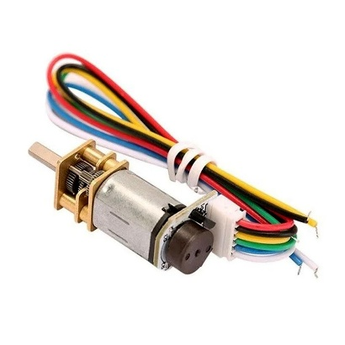
Buying - https://www.google.com/aclk?sa=L&ai=DChsSEwjBt_W42d6VAxWwgUsFHdwNKVoYACICCAEQARoCc2Y&co=1&ase=2&gclid=Cj0KCQjw6_HSBhCpARIsANvVltYWrYtKT5nJ1j7Uc811O90QsAHKQzrELVhh-P8jd8pza8WSa-6_hvsaAuRJEALw_wcB&cid=CAASugHkaAbb6bV76_gH5nVxDYdzo0kzSULgOlwntfyAAIkxqLR9c0W9wn4Qc_M6QjeRXubTwoc-lKLQtex5cg7ycyUmT_MU5geCLmB6oKjFNbQCSydGB7ZoxFn4HgeREbWhcdCHHnhhmrtRGl_xoz97u-0BW1R5WZLnGS76c7XpWRzNPgr69wWlHYWVV2OyN870x3h811jLhbYL9ZB_K5AIXwuHR-W9M4QkYOe-_Qv_Ns7feC88ZHdANP5DX8g&cce=2&category=acrcp_v1_32&sig=AOD64_0PHeRQPwB8SVgZnuC-Q2c4Fzbngg&ctype=5&q=&nis=4&ved=2ahUKEwjqk--42d6VAxU8XWwGHVV4J8cQ9aACKAB6BAgKEBA&adurl=

2S 350mAh 70C LiPo
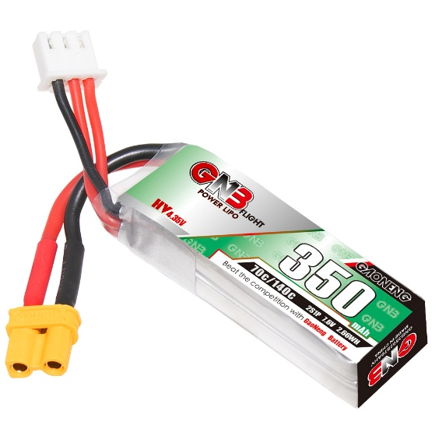
MPU6050 Gyroscope & Accelerometer Sensor Module (GY-521) – 6-Axis IMU
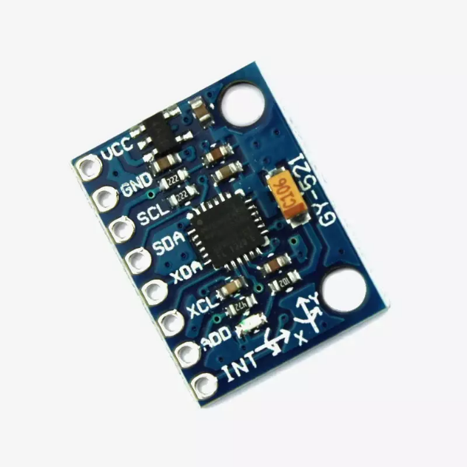
- Sensor IC: MPU6050 (also referred as GY-521)
- SKU:YTX25262014
- Sensing Axes: 6-Axis – 3-Axis Gyroscope + 3-Axis Accelerometer (MEMS)
- Supply Voltage (VCC): 3V – 5V DC
- Communication Interface: I2C (up to 400kHz Fast Mode)
- I2C Address: 0x68 (default) / 0x69 (AD0 HIGH) – Configurable
- ADC Resolution: 16-bit built-in ADC (high accuracy)
- Digital Motion Processor: Built-in DMP (offloads MCU processing)
- Temperature Sensor: Built-in onboard temperature sensor
- Auxiliary I2C: XDA / XCL pins for external sensor (e.g. magnetometer – 9-axis)
- Interrupt Pin: INT – FIFO buffer full indicator
- Output Type: Digital – I2C data frames (acceleration, gyro, temperature)
- Arduino Pins: SDA → A4, SCL → A5
- Compatibility: Arduino, ESP32, ESP8266, Raspberry Pi, STM32
Buying Link - https://www.yantronix.in/products/mpu6050-gyroscope-accelerometer-sensor-module-gy-521-%E2%80%93-6-axis-imu-with-dmp-for-arduino-raspberry-pi/1414116000002156903?srsltid=AfmBOorDHNStkDg8_hWdsdWBSwp0XPyLZqDI-a08qEbIQrgcgXs62NT0BkA

MCP3008 8-Channel 10-Bit A/D Converter with SPI Interface IC DIP-16 Package
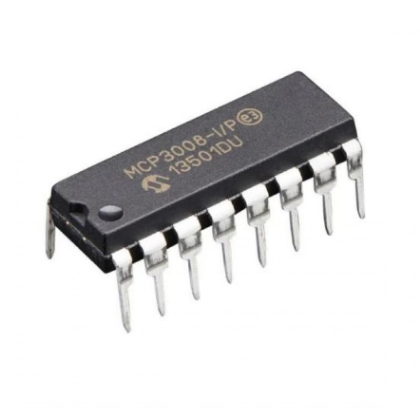
Buying link - https://www.electropi.in/mcp3008-8-channel-10-bit-a-d-converter-with-spi-interface-ic-dip-16-package

